**Sustainability Analysis of Two BNR Configurations to Mitigate Algae Blooms in San Francisco Bay**

Submitted by:

**BlueStream Innovations**

Nehal Jain, Buai Shi, Nina Trousdale, Linshui Zhang, Tejashree Babar, Sristi Shreya

December 20, 2024

**Executive Summary**

The San Francisco Bay area faces increasing algae blooms due to excessive nutrient discharge from wastewater treatment facilities. The San Francisco Public Utilities Commission is planning on upgrading the Southeast Treatment Plant, which handles 80% of San Francisco’s wastewater with a capacity of 85.4 million gallons per day, to reduce nitrogen levels in the effluent to 6 mg L-1. This study evaluated two biological nitrogen removal (BNR) configurations:

* Modified Ludzak-Ettinger (MLE) Process with a denitrification filter, and
* 4-stage Bardenpho Process.

The study utilized GPS-X, a wastewater modeling and simulation software, for system design and simulation. Techno-economic analysis (TEA) and life cycle assessment (LCA) were conducted to compare the economic and environmental sustainability of the two configurations. Monte Carlo simulations were performed for uncertainty analysis followed by sensitivity analysis to identify key drivers of cost and greenhouse gas emissions.

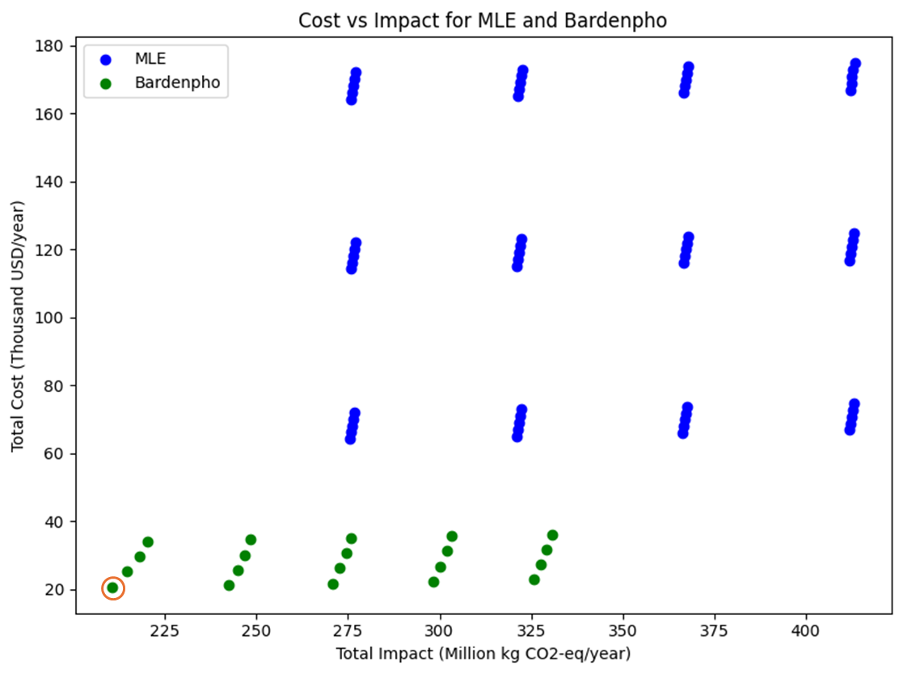

The 4-stage Bardenpho process emerged as the optimal solution with relatively lower annual costs ranging between $20,573 and $36,132 against MLE’s annual costs varying from $64,107 to $174,773. Environmental impact due to greenhouse gas emission was lower as well, varying from 29,833-340,956 tonnes CO2-eq. year-1. Bardenpho did not require any methanol addition as well, unlike the MLE process.

The recommended design is a Bardenpho configuration with a dissolved oxygen concentration of 0.5 mg L-1, a solids retention time of 31.4 days and no methanol addition required. This configuration provides the most cost-effective and environmentally sustainable solution for meeting the constraint on the total nitrogen concentration in the effluent.

1. **Introduction**

The algae blooms are particularly becoming more frequent in the San Francisco Bay Area and have been contributed majorly by nutrient discharge from wastewater. Consequently, the San Francisco Public Utilities Commission (SFPUC) is working on upgrading the Southeast Treatment Plant to lower the level of nitrogen in effluent. The goals are to apply efficient and inexpensive nitrogen removal technology and minimize the emission of greenhouse gases while satisfying a total nitrogen concentration of 6 mg L-1 in the effluent. The Southeast Treatment Plant is the largest wastewater treatment plant in the San Francisco Bay Area handling 80% of the city’s wastewater with a design capacity of 85.4 million gallons a day.

Given the critical need to prevent harmful algae bloom in the San Francisco Bay, this report evaluates the applicability of Biological Nitrogen Removal (BNR) processes to mitigate nitrogen discharge into the bay waters: the Modified Ludzak-Ettinger (MLE) process and the 4-stage Bardenpho process. The MLE process has an additional denitrification filter compared to the conventional configuration. The study analyses the system performance of these configurations using GPS-X, a wastewater treatment design and simulation software. Sustainability assessments, such as techno-economic analysis (TEA) and life cycle assessment (LCA), were further conducted for the configurations.

1.1 Nitrification and Denitrification

Nitrification and denitrification constitute the biological heart of the BNR process. Nitrification is a two-step aerobic process where ammonia (NH3) is first oxidized to nitrite (NO2-) by ammonia-oxidizing archaea (AOA) and ammonia-oxidizing bacteria (AOB), which is subsequently converted to nitrate (NO3-) by nitrite-oxidizing bacteria (NOB). This transformation is critical because ammonia and nitrite are toxic to aquatic life even at low concentrations. The process is highly oxygen-dependent, requiring precise control of aeration rates to optimize conversion efficiency.

Denitrification follows as an anoxic process, where nitrate (and nitrite) is reduced to nitrogen gas (N2) by heterotrophic bacteria using external carbon as an electron donor in the absence of oxygen. This conversion effectively removes nitrogen, preventing its release into receiving waters. Achieving stable denitrification requires balancing carbon availability, nitrate loading, and hydraulic retention times.

1.2 Key Factors in BNR Process Optimization

Several operational parameters influence the effectiveness of the BNR process. Methanol is commonly used as an external carbon source to supplement denitrification when the organic content in the influent wastewater is insufficient. Its rapid biodegradability ensures immediate microbial uptake, enhancing nitrate removal efficiency. Dissolved oxygen (DO) level is another crucial factor. High DO concentrations are essential in aerobic zones for efficient nitrification, while low or zero DO levels in anoxic zones prevent oxygen from disrupting the denitrification process. Internal recycling of mixed liquor from the aerobic zone back to the anoxic zone ensures a continuous supply of nitrate, enabling effective denitrification. The return of activated sludge is equally critical. Recycling sludge maintains a concentrated population of active microbial biomass, sustaining both nitrifying and denitrifying bacteria. This recycling balances microbial growth and ensures stable biological activity throughout the treatment process.

1.3 Comparative Configurations

To achieve optimal nitrogen removal, SFPUC is evaluating two established BNR configurations: the Modified Ludzak-Ettinger (MLE) process and the 4-stage Bardenpho process. The MLE process consists of an anoxic zone followed by an aerobic zone, facilitating biological denitrification and nitrification sequentially. A denitrification filter is appended to the secondary clarifier to obtain similar treatment performance as the 4-stage Bardenpho. The 4-stage Bardenpho process employs a more complex configuration with alternating anoxic and aerobic zones. This design includes an additional anoxic zone following the secondary aerobic stage, enabling further nitrate removal through extended denitrification. The incorporation of multiple zones ensures that nitrogen removal is maximized before effluent discharge. While the MLE process is operationally simpler, the Bardenpho process achieves more comprehensive nitrogen removal due to its secondary treatment tanks.

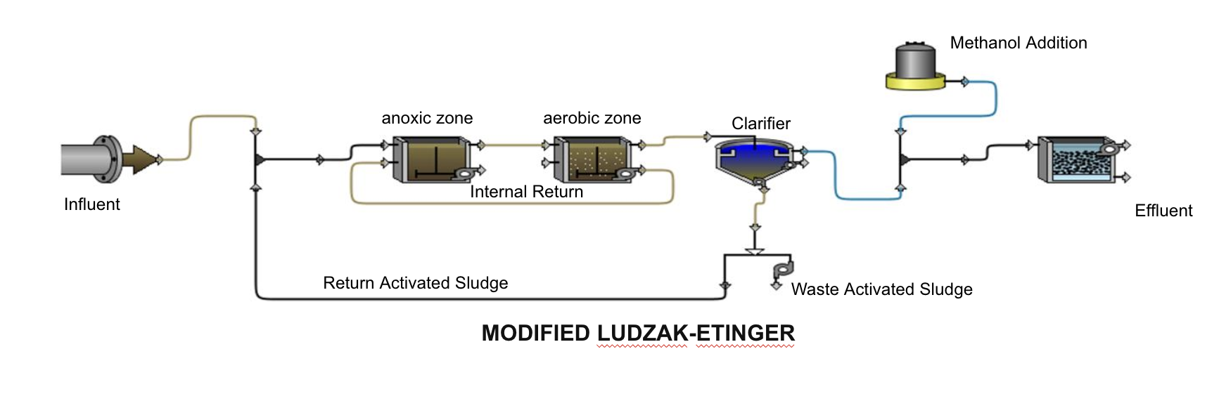(a)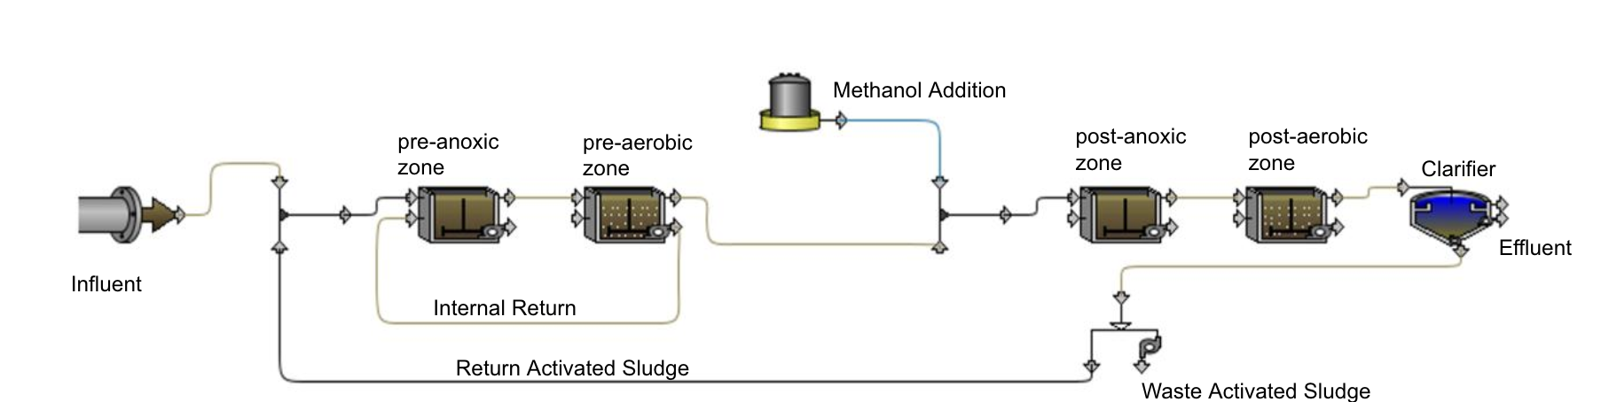

(b)

Figure 1: BNR configurations analysed: (a) Modified Ludzak-Ettinger (MLE) Process; (b) 4-Stage Bardenpho Process.

1. **Design Methodology**

​​ We focused on optimizing key parameters in BNR systems to achieve efficient nitrogen removal. The decision variables included Bioreactor Configuration, Dissolved Oxygen (DO), Solids Retention Time (SRT), and External Carbon Addition. Bioreactor configuration is a discrete variable and is either MLE or 4-stage Bardenpho. While both are effective, the Bardenpho process increases system footprint, aeration needs, and lifecycle costs due to additional tanks, whereas the MLE process, though simpler, requires a larger footprint and higher O&M costs. DO level is a continuous variable typically ranging from 2-4 mg L-1 for nitrification. SRT, ranging from 3-14 days, was optimized to support slow-growing nitrifying bacteria and improve substrate conversion, while avoiding the risks of microorganism washout with shorter SRTs. Methanol addition had a typical range of 3.3-3.8 g methanol/g NO₃-N removed [1,2].

2.1 Design basis

Decision variables were optimized using GPS-X, a wastewater modeling application. MLE and 4-stage Bardenpho processes were built in GPS-X with Mantis3 model, and medium strength wastewater was assumed for the influent flow [1]. Tank sizes were determined based on the influent flow rate of Southeast Treatment plant and the chosen hydraulic retention times (HRT) for individual tanks. Preliminary simulations were performed on typical HRT values, and the lowest HRT that led to low total nitrogen concentration in the effluent was chosen for each tank [1,3]. HRT values and other simulation related assumptions are listed in Appendix I. Combinations of DO concentrations and methanol addition were generated from the typical ranges of decision variables and then fed into the GPS-X as input parameters. SRT was calculated from wastage rate, a third input parameter evaluated in GPS-X. The output was total effluent nitrogen concentration with a target of 6 mg L-1. The original ranges for the decision variables were tuned and optimized to meet the total nitrogen concentration target, and only the decision variables values that meet the effluent constraint were kept in the decision space.

All optimized combinations of SRT, DO concentration, and methanol addition rates obtained from GPS-X simulations were then used to determine the material and equipment requirement over a lifetime of 50 years. Design equations and assumptions are listed in Appendices II and III, respectively. Using the flow rate at Southeast Treatment Plant and the fixed HRT values, dimensions were calculated for the reaction tanks and secondary clarifier, with assumed side water depths and depth to width ratio [1,2]. The dimensions of the denitrification filter in the MLE configuration were also calculated based on the influent flow rate and assumed hydraulic application rate. Based on the dimensions calculated, the quantities of concrete and steel for construction were determined, and the pipe lengths for internal return and return activated sludge were estimated [1]. The power of pumps was calculated from the assumed activated sludge return and the wastage rate determined through GPS-X simulations. The power of blowers was calculated from the DO concentration from GPS-X simulations [4,5].

2.2 LCC and LCA

Life cycle cost and environmental impact were analyzed for each combination of SRT, DO concentration and methanol addition rates and for both BNR configurations. The cost calculations included costs from construction and O&M. Construction costs consisted of upfront material requirements including pipes, concrete, reinforcement steel, denitrification filter media, and the first installment of mechanical equipment. Operation and maintenance costs included four categories: (i) the addition of methanol as external carbon source, (ii) electricity use for aeration and pumping, (iii) replacement of pumps and blowers (assuming 15-year lifetime), and (iv) sludge management. Labor and transportation costs were assumed to be similar for both the MLE and 4-stage Bardenpho configurations and therefore not included in the comparison of configurations. Unit costs of construction material and mechanical equipment specific to San Francisco were obtained from RSMeans [6], and equations for inventory calculations are provided in Appendix II. The cost of electricity ($ kWh-1) was calculated as the average of on-peak, part-peak, and off-peak charges for industrial customers [7]. All costs were first converted to present worth and then to annual cost for a 50-year lifetime with an interest rate of 5% [8,9].

For the life cycle analysis, the functional unit was maintaining a total nitrogen concentration below 6 mg L-1 in the annual flow at the Southeast water plant. The annual carbon dioxide emission equivalence was calculated for both configurations and compared. The LCA included all items from construction and O&M that were considered in TEA mentioned previously. In addition, fugitive emissions from BNR processes and transportation of material were also calculated [9,10]. Unit impacts were calculated in OpenLCA using the OzLC2019 and Ecoinvent databases, and inventory calculation methods can be found in Appendix II [11,12].

2.3 Uncertainty and sensitivity analyses

The optimal design alternative with the least cost and environmental impact was determined from the LCC and LCA results. Uncertainty and sensitivity analyses were performed for the optimal design to obtain more accurate ranges of the cost and impact and to investigate what parameters had the most contributions to the uncertainties. There were over 30 uncertain parameters from both the configurations. These were grouped into three categories: design parameters (affected both costs and environmental impacts), unit costs (affected only costs) and unit impacts (affected only environmental impacts). The uncertainty ranges of all parameters in the analysis with their probability density functions were provided in Appendix III. If for a parameter, only the range was available in literature, a uniform distribution was assumed. If only a single value was available for parameters such as unit costs or unit impacts, a uniform distribution was assumed with lower bound being 80% of the single value and higher bound being 120% of the value.

For uncertainty analysis, 5000 Monte Carlos simulations were performed to generate the uncertainty ranges of LCC and LCA analysis. For global sensitivity analysis, the Spearman’s rank correlation coefficients were calculated for the ranks of each parameter and either life cycle cost or environmental impact. The Spearman’s correlation coefficients range from -1 to 1, and a coefficient further away from 0 indicates greater contribution of the parameter to the uncertainty of LCC or LCA.

1. **Relative Sustainability of Design Alternatives**

Viable combinations of SRT, DO concentration, and methanol addition rate that satisfied the 6 mg L-1 target of total nitrogen in the effluent were obtained from GPS-X simulations. The final ranges of the decision variables differed but were comparable to typical ranges cited from Metcalf & Eddy. For modified MLE, the wastage rate ranged from 0.6% – 1.8% of the influent flow rate, corresponding to an SRT range of 7 to 20 days. The dissolved oxygen concentration ranged from 0.5 mg L-1 – 2 mg L-1, and the methanol addition rate was 5 m3.d-1 – 15 m3.d-1. For 4-stage Bardenpho, the literature ranges of DO concentration and SRT led to consistently low total nitrogen concentration without methanol addition, therefore no external carbon was used in simulations for the 4-stage Bardenpho. The wastage rate ranged from 0.8% - 2.9% of the influent flow, leading to an SRT of 11 – 31 days. The DO concentration was kept the same for the primary and secondary aerobic tanks, ranging from 0.5 mg L-1 – 2 mg L-1.

The total cost and total environmental impact were calculated for all designs that met the effluent nitrogen concentration limit. Based on the analysis, the Bardenpho designs are consistently less expensive, with costs between $20,573 and $36,132 per year as compared to $64,107 to $174,773 per year for MLE (Fig. 2). The ranges of environmental impacts overlap for the two configurations. Bardenpho impacts range from 229,833 to 340,956 tonne CO2-eq.year-1, while MLE impacts range from 275,589 to 413,355 tonne CO2-eq.year-1 (Fig. 2).

Results formed a grid-like pattern because combinations of discrete options were used for the decision variables (Fig. 2). The axis of the Bardenpho design space that is nearly vertical corresponds to changes in the value of the SRT variable (Fig. 2). Therefore, the total cost is reduced by increases in SRT. Increasing the SRT reduces the volume of waste activated sludge, decreasing the cost of solid management and disposal. The Bardenpho axis that is nearly horizontal corresponds to changes in the value of the DO decision variable (Fig. 2). When less DO is used, less power is required for the blower, so electricity consumption decreases.

Unlike the Bardenpho designs, the MLE designs formed clusters (Fig. 2). The marginal reductions in cost resulted from increases in SRT, as with Bardenpho. However, the large shifts in cost between clusters are caused by changes in the value of the methanol decision variable, which directly affects the material cost of the project.

The optimal design, situated closest to the bottom left of the graph, had both the lowest total cost and lowest total environmental impact (Fig. 2). The decision variable values for the optimal design are a Bardenpho configuration, a DO level of 0.5 mg L-1, and an SRT of 31.4 days. The lowest DO level tested was 0.5 mg L-1, while the highest SRT value was 31.4 days, underscoring that decreasing DO levels reduces impacts and increasing SRT reduces cost.

1. **Recommendation**

The recommended design is a Bardenpho configuration with a DO level of 0.5 mg L-1 and an SRT of 31.4 days. Of the designs that meet the effluent nitrogen concentration limit, this Bardenpho design has both the lowest cost and least environmental impact with the benefit of no addition of methanol. Uncertainty and sensitivity analyses were conducted for the optimal design and the best MLE design (DO of 0.5 mg L-1, SRT of 20.3 days, and methanol addition of 5 m3 per day). The uncertainty analysis suggested that the performance advantage of Bardenpho is robust across various scenarios of technological and contextual parameters. As is seen in Fig. 3, both configurations have very similar variations in uncertainty and outlier patterns. However, Bardenpho offers a more reliable performance. While in some scenarios, there is an overlap between the environmental impacts of MLE and Bardenpho, Bardenpho lowers the median environmental impacts by at least a 1000 million kg CO2-eq. every year. The metric that drives all the difference between the two configurations is the total costs. Bardenpho reduces the median costs by around $600,000 per year.

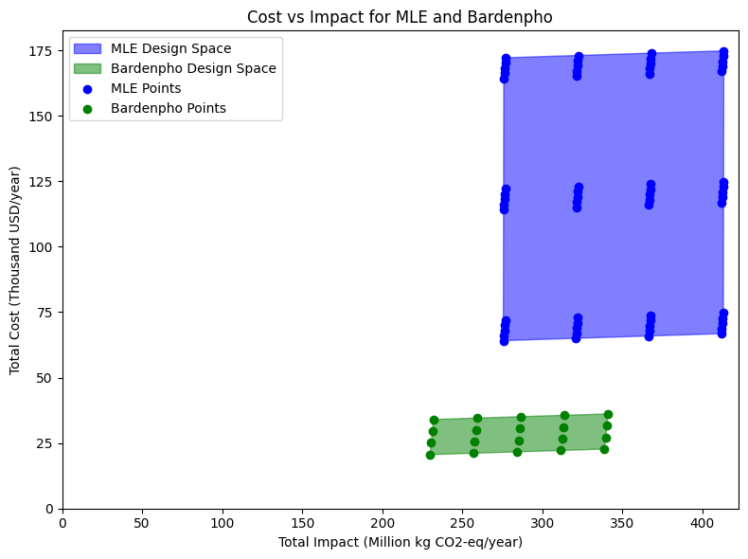

Figure 2: Cost and impact comparison of MLE and Bardenpho configurations.

A more holistic understanding of the costs and environmental impacts from the two configurations was obtained by analysing the contributions of the different life cycle phases. Fig. 4 shows how these life cycle phases stand with respect to each other. We considered the construction, operation and maintenance phases. The end of life phase was not included in the analysis, since we assumed the pipes and basins would remain in place at the end of the project lifetime. For costs, the construction phase comprised capital costs and replacement costs for mechanical equipment, while the operation phase covered all the operation and maintenance costs.

Evidently, from Fig. 4, the operation phase is the primary driver for the economic difference between the two configurations, especially economically. The overlap in environmental impacts of the two configurations arrives from the operational phase. The construction costs for Bardenpho are higher than that for MLE since it has more treatment units with larger basins. The operational costs, on the other hand, are higher for MLE primarily due to methanol, its purchase, transportation and pumping.

Sensitivity analysis aided in identifying key leverage points for system optimization. Oxygen transfer efficiency and other electricity-related parameters had a relatively high Spearman's rank correlation coefficient, as shown in Fig. 5. The sensitivity of a metric to a parameter is dependent on two factors: (a) the size of the parameter range or distribution that affect the potential variation in the metric, and (b) the non-linear relationship between the input parameter and the metric that can create varying levels of sensitivity across the parameter range [13]. While the range of oxygen transfer efficiency and recycle activated sludge (RAS) ratio is wide, they also dictate the blower and pump powers respectively, thus, the electricity consumption. Pump and blower efficiency also play a very critical role in electricity consumption.

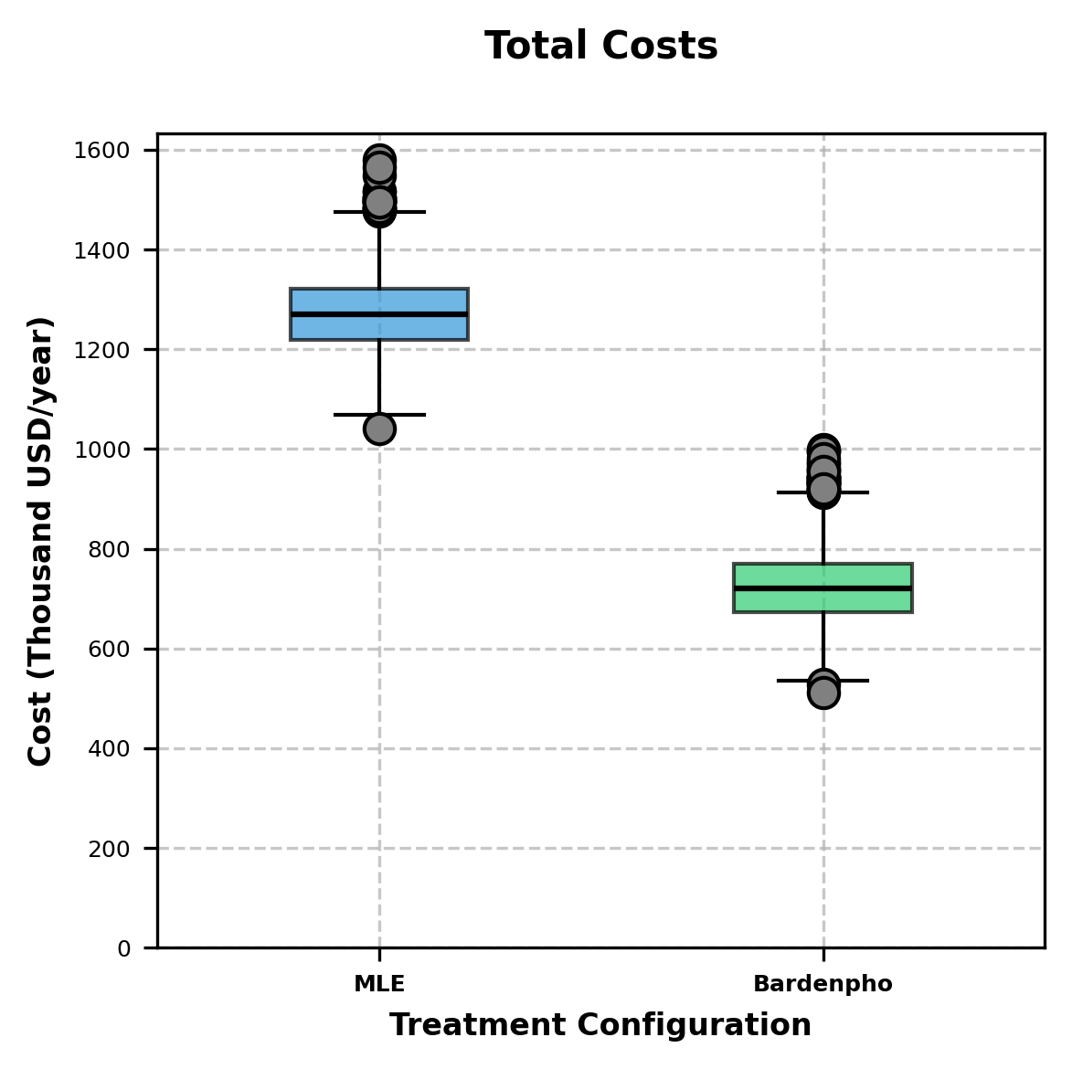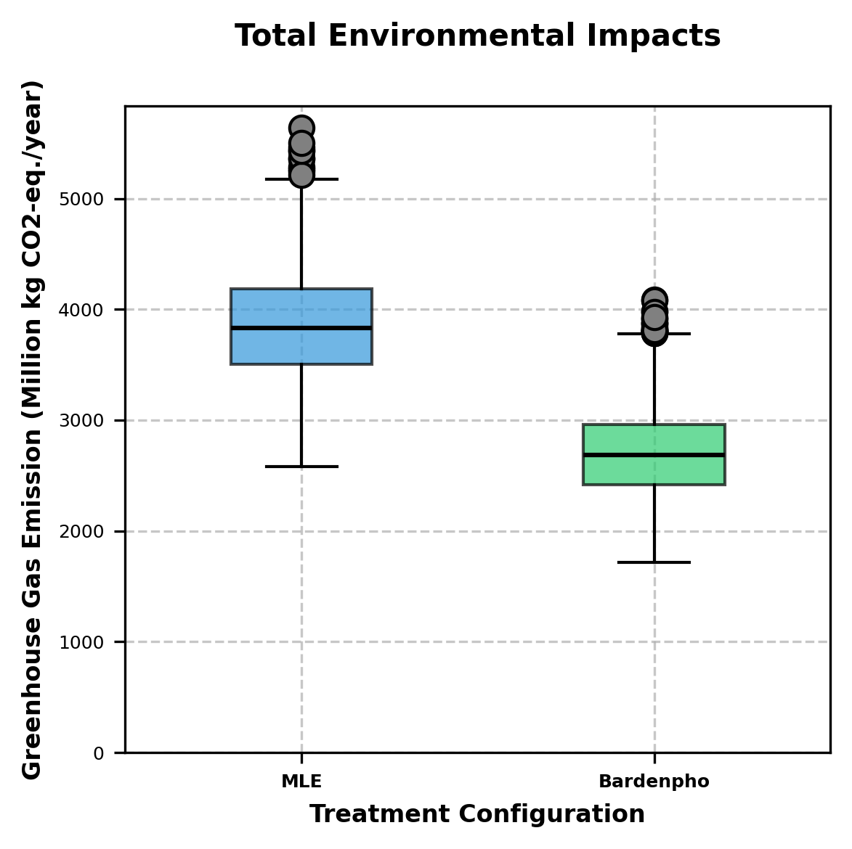

(a) (b)

Figure 3: Uncertainty analysis comparison of MLE and Bardenpho configurations for (a) Total costs, and (b) Total environmental impacts.

(a) (b)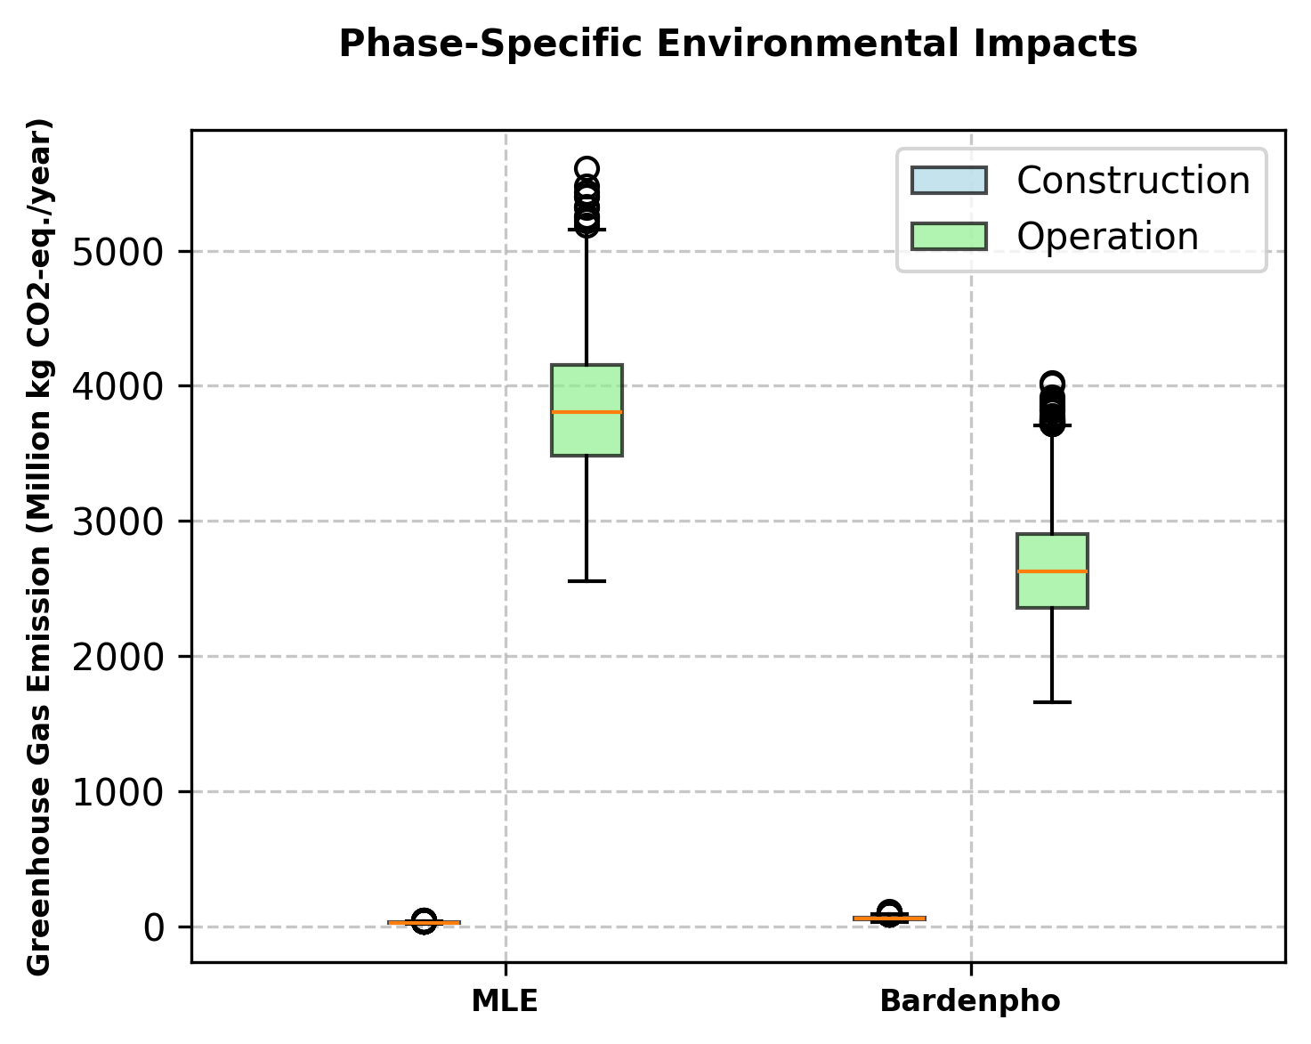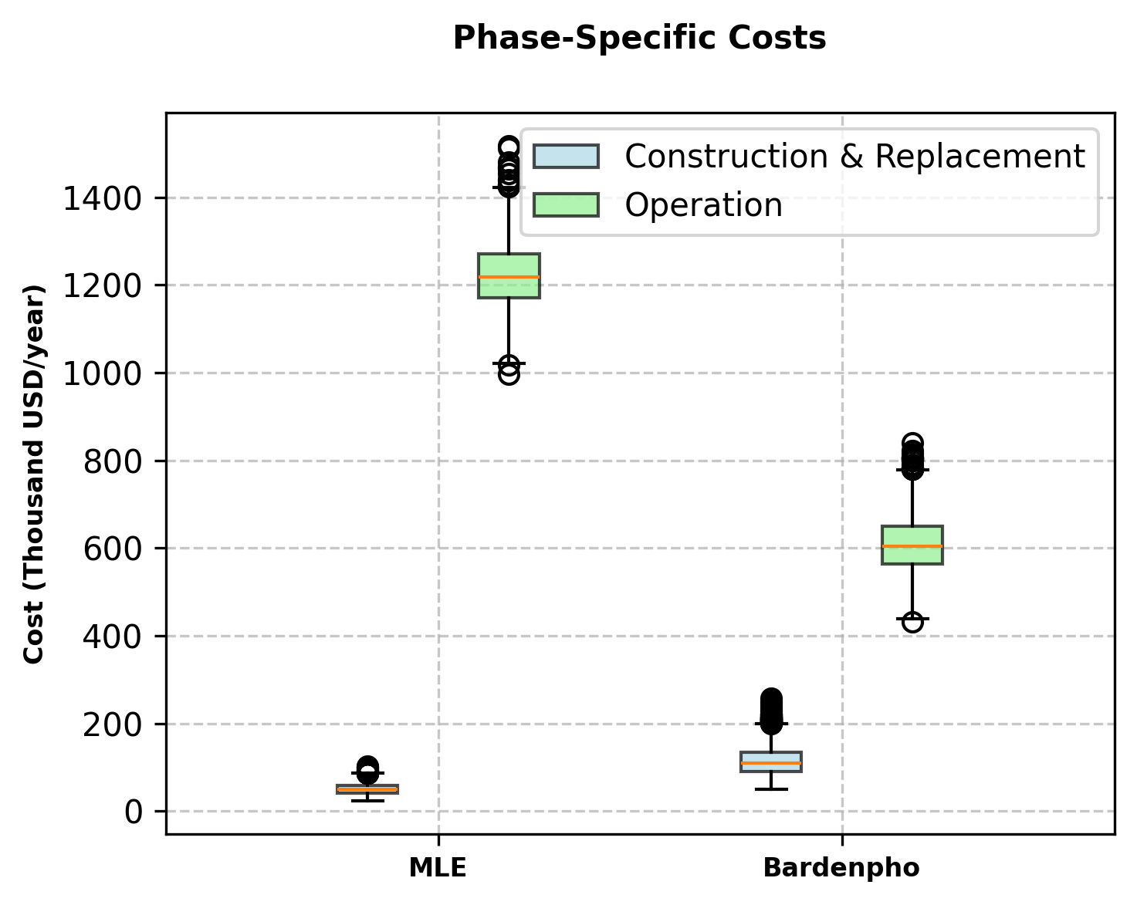

Figure 4: Phase-specific uncertainty analysis of MLE and Bardenpho configurations for (a) costs, and (b) environmental impacts.

These parameters can be leveraged to optimize electricity consumption, thereby maximizing the economic and environmental benefits that the Bardenpho configuration offers. The following are a few practices we recommend to optimize system performance.

1. Fine bubble diffusers can be implemented to improve oxygen transfer efficiency, by providing a greater surface area for oxygen diffusion. A higher oxygen transfer efficiency requires a lower supply of air, hence lowering energy consumption.
2. The mixed liquor suspended solids (MLSS) concentration can be monitored regularly via sensors to automate and optimize the RAS flow from secondary clarifiers to the bioreactors. In addition to process stability, this would avoid unnecessary pumping, thereby minimizing electricity consumption.
3. High efficiency pumps and blowers directly minimize electricity consumption.
4. **Conclusions**

The San Francisco Public Utilities Commission (SFPUC) is expanding the wastewater treatment facilities in and around San Francisco to incorporate biological nutrient removal to mitigate algae blooms. The SFPUC approached us to propose a biological nitrogen removal (BNR) configuration for the largest wastewater treatment plant in San Francisco, the Southeast Treatment Plant. This study evaluates the relative sustainability of 2 BNR configurations: Modified Ludzak-Ettinger (MLE) and 4-stage Bardenpho. The goal is to reduce the total effluent nitrogen concentration below 6 mg L-1, while minimizing costs and environmental impacts.

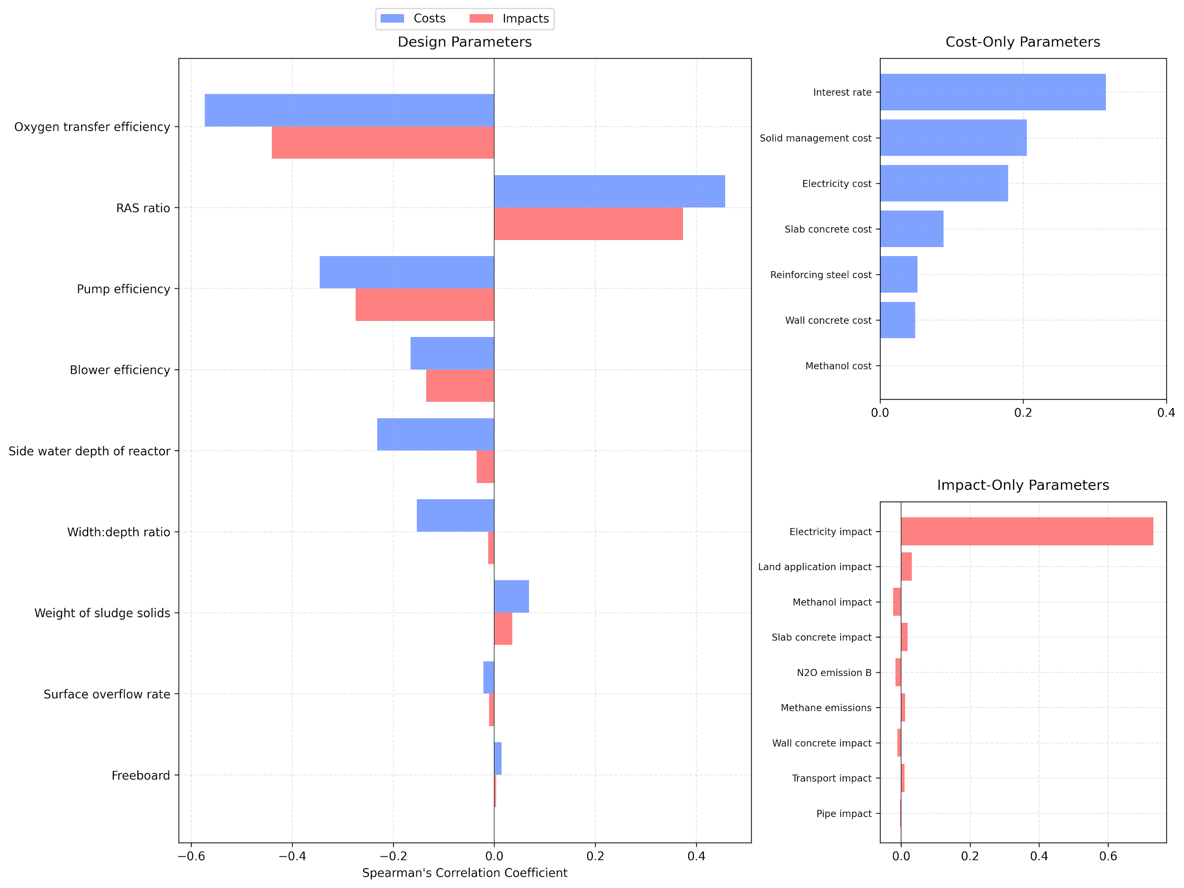

Figure 5: Average Spearman's rank correlation coefficient for different parameters affecting costs and environmental impacts for the Bardenpho configuration.

The 4-stage Bardenpho configuration emerged as the optimal upgrade to the plant’s nitrogen removal capabilities, demonstrating superior performance in both economic and environmental metrics compared to the MLE configuration. The most efficient design utilizes a dissolved oxygen (DO) concentration of 0.5 mg/L and a solids retention time (SRT) of 31.4 days with no addition of methanol required. These parameters surpass the required effluent quality while minimizing the operational costs and environmental impacts, with the advantage of no addition of methanol. The low DO concentration reduces electricity consumption, and the high SRT leads to better nitrogen removal and reduced waste activated sludge production. The process can further be optimized by optimizing oxygen transfer efficiency and recycle activated sludge ratio, and implementing high efficiency pumps and blowers.

Hence, the 4-stage Bardenpho configuration can effectively mitigate the algae blooms and nutrient pollution in the San Francisco Bay, while maintaining operational reliability and cost effectiveness.

**References**

[1] Tchobanoglous, G.; Stensel, H. D.; Tsuchihashi, R.; Burton, F. L.; Abu-Orf, M.; Bowden, G.; Pfrang, W. Chapter 9-7 Attached Growth Denitrification Processes. *Wastewater Engineering: Treatment and Resource Recovery*; McGraw-Hill Education, **2014**.

[2] Grady, L. *Biological Wastewater Treatment*; Iwa Pub./Crc Press: Boca Raton, Fl, **2011**.

[3] Recommended BNR/ENR Design Criteria.

<https://mde.maryland.gov/programs/water/BayRestorationFund/Documents/www.mde.state.md.us/assets/document/BRF-DraftDesignCriteriaEligibilityDet.pdf>

[4] Wastewater Management Fact Sheet Denitrification Filters. https://www.epa.gov/sites/default/files/2019-08/documents/denitrifying_filters_fact_sheet_p100il79.pdf (accessed 2024-10-09).

[5] Perry, R.H. & Green, D.W. (2008). *Perry's Chemical Engineers' Handbook, 8th Edition*. McGraw-Hill Education.

[6] RSMeans. (2023). *RSMeans Online Construction Cost Data*. Retrieved from<https://www.rsmeans.com>.

[7] San Francisco Public Utilities Commission. (2023). Rate Schedules & Fees for Hetch Hetchy Power and CleanPowerSF. Retrieved from <https://www.sfpuc.gov/sites/default/files/accounts-and-services/Rates_Schedule_HHP_CleanPowerSF_2023-24.pdf>.

[8] Johnson, M. What is a typical wastewater treatment plant life expectancy?. Fehr Graham.

[9] San Francisco Public Utilities Commission. *2018 Water and Wastewater Cost of Service.* **2018**. Study. Retrieved from https://www.sfpuc.gov/sites/default/files/agendas-minutes-rate-fairness-board/2018%20Water%20and%20Wastewater%20Cost%20of%20Service%20Study.pdf (accessed 2024-10-22).

[10] Calvo Buendia, E., Tanabe, K., Kranjc, A., Baasansuren, J., Fukuda, M., Ngarize, S., Osako, A., Pyrozhenko, Y., Shermanau, P. and Federici, S. *2019 Refinement to the 2006 IPCC Guidelines for National Greenhouse Gas Inventories*. IPCC **2019**. Published: IPCC, Switzerland. <https://www.ipcc-nggip.iges.or.jp/public/2019rf/index.html>.

[11] The Evah OzLCI2019 Free Database integrated with the OpenLCA LCIA Methods v2.0.2.OzLCI2019.

[12] Ecoinvent Database. <https://ecoinvent.org/>

[13] Marino S, Hogue IB, Ray CJ, Kirschner DE. A methodology for performing global uncertainty and sensitivity analysis in systems biology. J Theor Biol. 2008 Sep 7;254(1):178-96. doi: 10.1016/j.jtbi.2008.04.011. Epub 2008 Apr 20. PMID: 18572196; PMCID: PMC2570191.

[14] Marshall, L. Air Backwash Blower System for Water Treatment Plant. <https://www.pdblowers.com/air-backwash-blower-system-for-water-treatment-plant/>

[15] Foley, J., De Haas, D., Hartley, K., & Lant, P. *Comprehensive life cycle inventories of alternative wastewater treatment systems.* Water Research, 44(5), 1654–1666, **2010**. <https://doi.org/10.1016/j.watres.2009.11.031>

[16] Water Environment Federation. *Design of Water Resource Recovery Facilities, Manual of Practice No. 8*; New York, N.Y Mcgraw-Hill Education, **2018**.

[17] Cashman, S., Arden, S., Morelli, B., Gray, J., Bartram, D., & Falatko, D. *Life Cycle and Cost Assessments of Nutrient Removal Technologies in Wastewater Treatment Plants*. Technical Report, EPA, Eastern Research Group. **2021**.

[18] Perry, R.H. & Green, D.W. (2008). *Perry's Chemical Engineers' Handbook, 8th Edition*. McGraw-Hill Education.

[19] Peccia, J; Westerhoff, P. We Should Expect More out of Our Sewage Sludge. *Environmental Science & Technology* **2015**, 49 (14), 8271-8276. DOI: 10.1021/acs.est.5b01931.

[20] Lindeburg, M. Civil Engineering Reference Manual for the PE Exam, 15th Edition; PPI, **2015**.

[21] Greenhouse gas Equivalencies Calculator.  
<https://www.epa.gov/energy/greenhouse-gas-equivalencies-calculator>.

[22] Bastian, Robert. The biosolids (sludge) treatment, beneficial use, and disposal situation in the USA. *Eur. Water Pollut. Control.* **1997**. 7,62− 79.

**Appendix I – GPS-X simulation settings and assumptions**

**Table 1. Influent wastewater characteristics and properties.**

| **Composition** | **Setting** |
| --- | --- |
| Design influent flow rate | 85.4 MGD |
| Total chemical oxygen demand (COD) | 508 g COD m-3 |
| Total Kjeldahl Nitrogen (TKN) | 36 g N m-3 |
| Readily biodegradable fraction of total COD | 0.3 |

**Table 2. HRT values for individual tanks in modified MLE and 4-stage Bardenpho.**

| **Tank** | **HRT** |
| --- | --- |
| Anoxic tank, MLE | 1 hr |
| Aerobic tank, MLE | 6 hr |
| Primary anoxic tank, Bardenpho | 3 hr |
| Primary aerobic tank, Bardenpho | 15 hr |
| Secondary anoxic tank, Bardenpho | 2 hr |
| Secondary aerobic tank, Bardenpho | 0.5 hr |

**Table 3. Key simulation settings for influent quality and unit processes in GPS-X.**

| **Input parameter** | **Setting** |
| --- | --- |
| Tank depth, anoxic and aerobic tanks including freeboard | 6.5 m |
| Aeration method | Diffused aeration |
| Return activated sludge | 75% of influent flow |
| Denitrification filter bed depth | 2 m |
| Denitrification filter bed surface | 51 m2 |
| Internal rate of return | 150% of influent flow |

**Appendix II-A - Design equations**

1. *Denitrification filter design* [1]

Total filter area: Eq. 1

Area per filter: Eq. 2

DNF tank length: Eq. 3

Air and water backwash flow rates:

Eq. 4

Eq. 5

Volume of backwash water per day:

Eq. 6

Total bump water volume:

Eq. 7

1. *Pumps and blowers* [2,14]

Air Flow Rate:

Rate of oxygen input: Eq. 8

Where: = required air flow rate, m3 s-1

RO = Required dissolved oxygen obtained from GPS-X, converted to kg hr-1.

= Percentage of oxygen transferred to the liquid phase, and varies between 6-15%

Blower power: Eq. 9

C = 289.7 for SI units

PW = power requirement (kW)

W = weight of flow of air (kg s-1)

R = engineering gas constant for air = 8.314 J mol-1 K-1

T1 = absolute inlet temperature = 293.15 K.

P1 = absolute inlet pressure = 1.532 atm (atmospheric pressure + water pressure, assuming 5.5 meters)

P2 = absolute outlet pressure = 1 atm

We will use the inlet and outlet pressure from commercial blowers

n = (k-1)/k = 0.283 for air

E = efficiency (usually 0.7 < e < 0.9)

Pump power: Eq. 10

Where,  
P = Power (kW)  
Q = Flow rate (m³/s)  
ρ = Density of water (1000 kg/m³)  
g = Acceleration due to gravity (9.81 m/s²)  
H = Static Head (m)  
η = Pump efficiency (typically 0.6 < e < 0.75)  
  
In our study, friction losses and pressure-drop are considered negligible. So, the Total Dynamic Head (TDH) will only consist of the static head.

1. *Reactor Calculations* [1,15]

The cross-sectional area of the tank: Eq. 11

Where A is the cross-sectional area in m2, V is the tank volume and SWD is side water depth.

The width of the tank: Eq. 12

The length of the tank: Eq. 13

For simplifying volumetric calculations for construction materials, we considered short walls, long walls and slabs.

Volume of short walls: Eq. 14

Volume of long walls: Eq. 15

Volume of slabs: Eq. 16

Volume of concrete: Eq. 17

Eq. 18

Reinforcement steel: Eq. 19

1. *Clarifier Calculations* [1,15,16]

The cross-sectional area of the clarifier: Eq. 20

Where A is the cross-sectional area in m2, Q is the influent flow rate and SOR is the surface overflow rate.

The clarifier diameter: Eq. 21

The side water depth of the clarifier varies with the diameter of the clarifier.

Cylindrical volume: Eq. 22

Volume of slab: Eq. 23

Volume of concrete: Eq. 24

Reinforcement steel: Eq. 25

**Appendix II-B Life Cycle Cost**

1. *Construction costs* [6]

Eq. 26

Eq. 27

Eq. 28

1. *Purchase and installation costs* [1,17]

Eq. 29  
*Cost of pumps = Number of pumps × Base pump cost × Installation factor* Eq. 30  
*Cost of blowers = Number of blowers × Base blower cost × Installation factor* Eq. 31  
*Pipe Cost = (Unit Cost of Pipe + Installation Cost) × Length of Pipe* Eq. 32

Eq. 33

Eq. 34

1. *Operation and Maintenance costs* [18,19]

Eq. 35

The annual electricity costs for blowers and pumps, assuming 24-hour operation:

Eq. 36

The solid management and disposal chain involves dewatering, storing, hauling and land application in agricultural fields as biofertilizers.

Eq. 37

*Annual pipe maintenance Cost = Maintenance Cost per Foot × Length of Pipe* Eq. 38

1. *Cash flow analysis*

Assumptions: [8,9]

Design life of the system: 50 years

Design life of mechanical equipment (pumps and blowers): 15 years

Pipes and basins stay in place at the end of the project lifetime.

For electricity costs, assuming 24 hour operation for the pumps and blowers.

Interest (or discount) rate: 5% assumed by the San Francisco Public Utilities Board in 2019.

Cost conversion: [20]

Conversion of future replacement costs for mechanical equipment to present worth:

Eq. 39

Conversion of present worth into equivalent annual worth:

Eq. 40

**Appendix II-C - Inventory calculations in life cycle analysis**

1. *Construction* [11,12]

DNF media:

Eq. 41

Eq. 42

Concrete:

Eq. 43

Eq. 44

Pipes:

Impact of pipes = Length of pipes × unit impact of pipes Eq. 45

Transportation:

Eq. 46

1. *Operation and Maintenance* [10,11,12]

Electricity:

To determine the total hours of operation, we assumed a 24-hour operation, 365 days a year:

Eq. 47

Eq. 48

Solids management:

N2O emissions from the sludge solids:

Eq. 49

Where it is assumed that the weight of N is 4.2% of the weight of the sludge solids.

Methanol Consumption:

Eq. 50

Emissions from biological treatment processes:

Eq. 51

Conversion factor for kg N2O-N to kg CO2-eq: [21]

Eq. 52

Conversion factor for kg CH4 to kg CO2-eq: [21]

**Appendix III - Parameter uncertainties**

**Table 4. Probability distributions for parameters for uncertainty analysis.**

| **Parameter** | **Values** | **Units** | **Distribution** | **Citation** |
| --- | --- | --- | --- | --- |
| **Parameters contributing to uncertainty during Construction** | | | | |
| Side water depth, SWD, of bioreactor | 4.5-7.5 | m | Uniform | [1] |
| Freeboard, FB | 0.3-0.6 | m | Uniform | [1] |
| Width:depth | 1-2.2 (1.5) | unitless | Triangular | [1] |
| Surface overflow rate, SOR | 24-32 | m3 m-2 d-1 | Uniform | [1] |
| Recycle activated sludge (RAS) ratio, R | 0.5-1.5 (1) | unitless | Triangular | [1] |
| Hydraulic application rate, DNF | 2.4-4.8 | m hr-1 | Uniform | [1] |
| Backwash flow rate, DNF | 14-22 | m3 m-2 h-1 | Uniform | [1] |
| Bump water flush rate, DNF | 10-14 | m3 m-2 hr-1 | Uniform | [1] |
| Air backwash rate | 72-96 | m3 m-2 h-1 | Uniform | [1] |
| **Parameters contributing to uncertainty during Operation** | | | | |
| Weight of sludge solids | 82-130 (98) | kg 10-3 m-3 | Triangular | [1] |
| Pump Efficiency | 60-75 | % | Uniform | [1] |
| Blower Efficiency | 70-90 | % | Uniform | [1] |
| Oxygen transfer efficiency | 6-15 | % | Uniform | [7] |
| **Parameters contributing to uncertainty during LCC/TEA (unit costs)** | | | | |
| Electricity price | 0.09561 (0.025) | $ kWh-1 | Lognormal | [6] |
| Wall concrete unit cost | 320.18-480.28 | $ m-3 | Uniform | [6] |
| Slab concrete unit cost | 69.95-111.93 | $ m-2 | Uniform | [6] |
| Steel unit cost | 1.30-2.08 | $ kg-1 | Uniform | [6] |
| Unit cost of solid management | 0.3-0.8 | $ kg-1 | Uniform | [17,22] |
| Filter sand, DNF | 38.37–57.55 | $ m-3 | Uniform | [6] |
| Supporting gravel, DNF | 35.63–53.45 | $ m-3 | Uniform | [6] |
| Methanol | 0.327-0.366 | $ kg-1 | Uniform | [17] |
| **Parameters contributing to uncertainty during LCA (unit impact)** | | | | |
| Wall concrete | 463.4–695.09 | kg CO2 eq m-3 | Uniform | [11] |
| Slab concrete | 312.23–468.34 | kg CO2 eq m-2 | Uniform | [11] |
| Pipes | 2.855–4.283 | kg CO2 eq m-1 | Uniform | [11] |
| DNF filter sand | 0.018–0.026 | kg CO2 eq kg-1 | Uniform | [11] |
| DNF gravel support | 0.018–0.026 | kg CO2 eq kg-1 | Uniform | [11] |
| Transportation | 0.862–1.292 | kg CO2 eq metric ton-1 km-1 | Uniform | [11] |
| Electricity | 0.449–0.673 | kg CO2 eq kWh-1 | Uniform | [12] |
| Land application of sludge | 0.008–0.012 | kg N2O-N (kg N)-1 | Uniform | [10] |
| Methanol | 1.007–1.51 | kg CO2 eq kg-1 | Uniform | [11] |
| Fugitive CH4 emissions | 0.014–0.022 | kg CH4 (kg BOD)-1 | Uniform | [10] |
| Fugitive N2O emissions | 0.0029–0.0043 (Bardenpho), 0.0006 to 0.0007 (MLE) | kg N2O-N (kg N)-1 | Uniform | [10] |